This Is A Previous Project + Transaction Extention
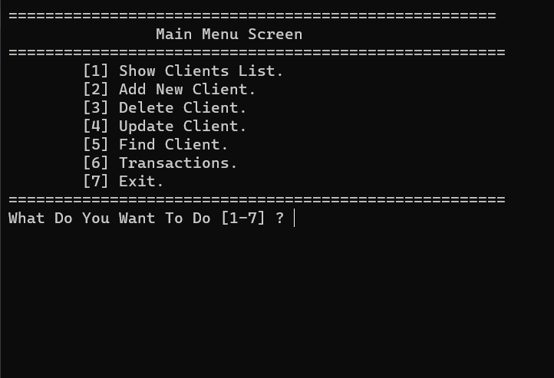

1-Show Clients List From A File (Like Data Base) Inside Project .
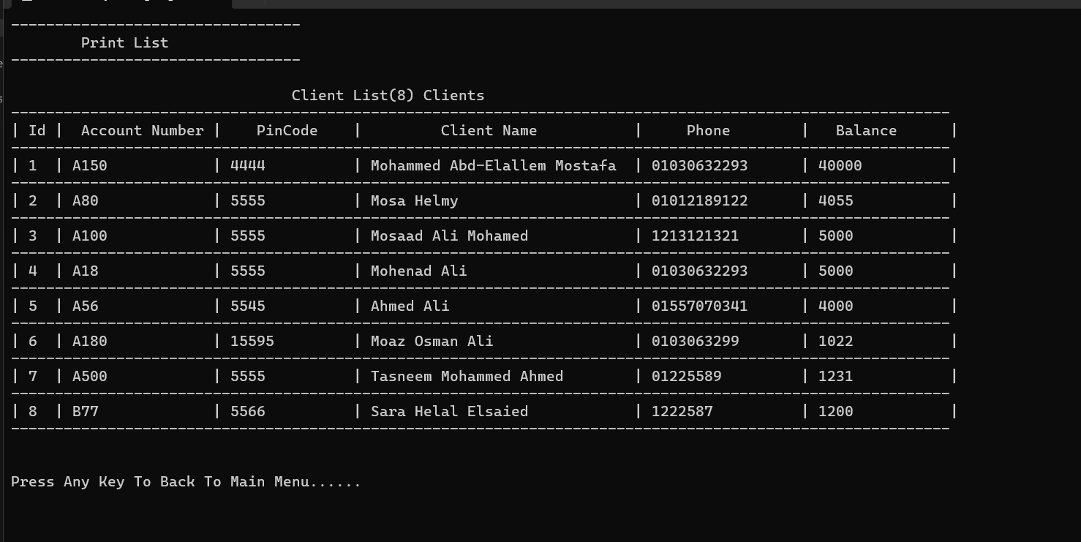

2-Add New Client To The File .
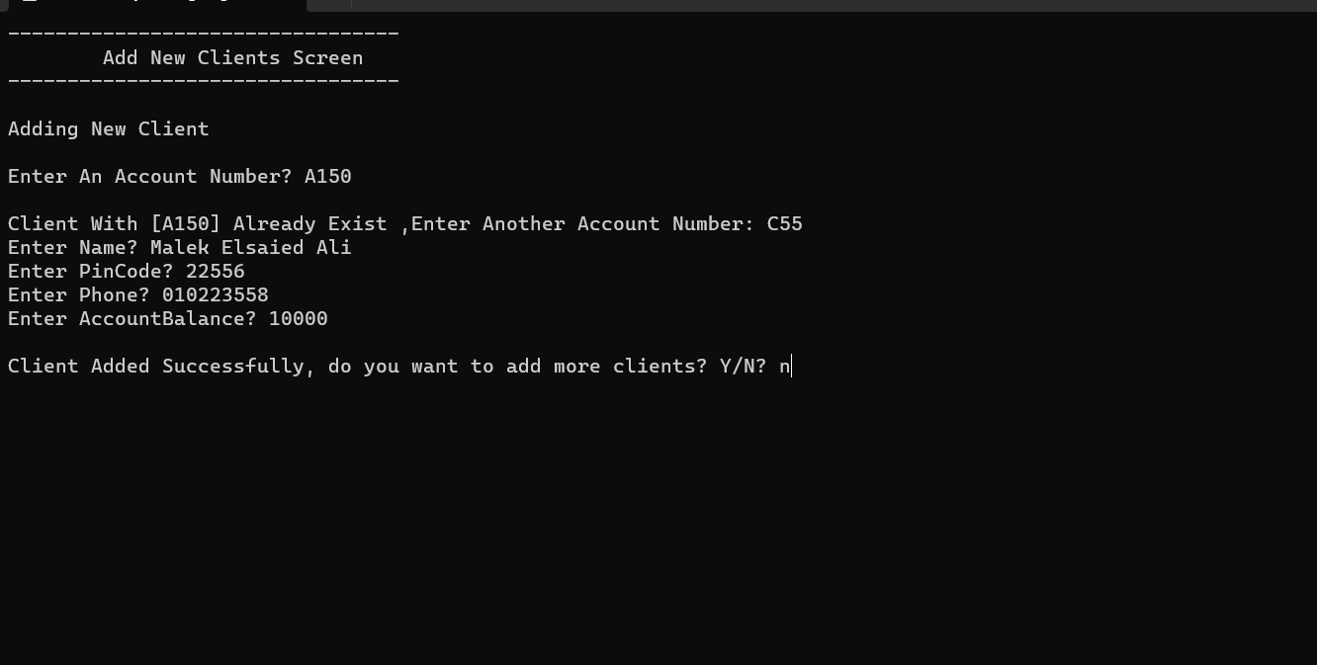

3-Delete Client From The File.
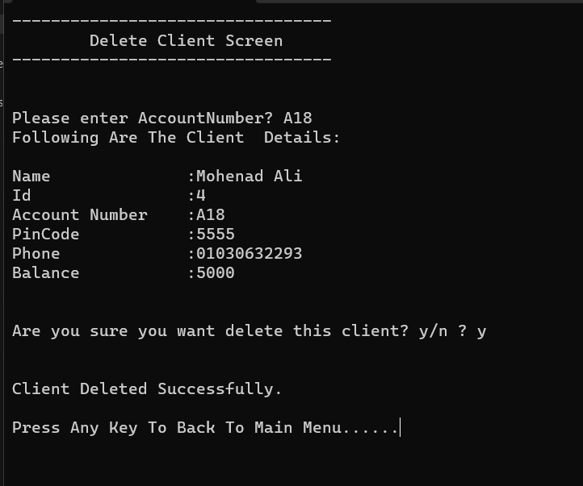

4-Update Client From The File.
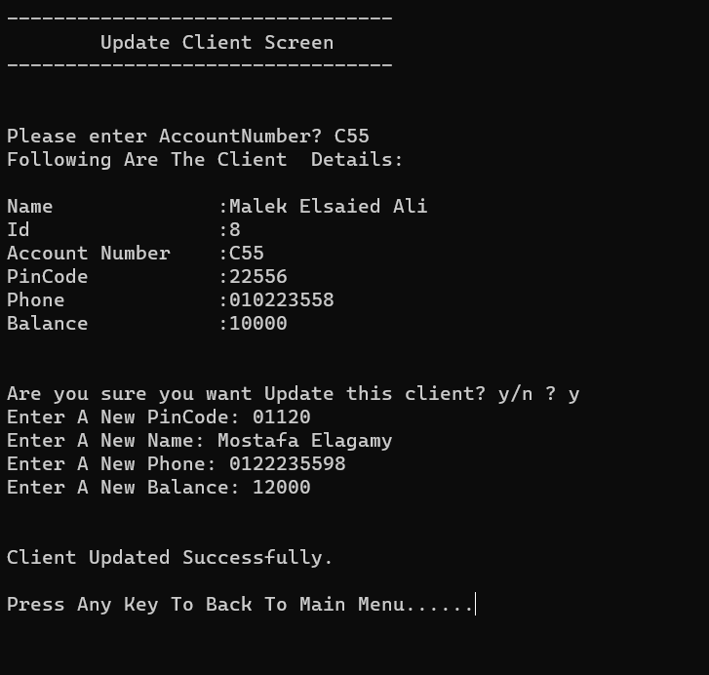

5-Find Client From The File.
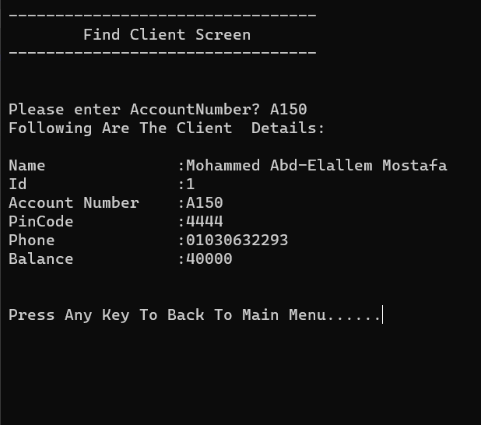

6-Transactions

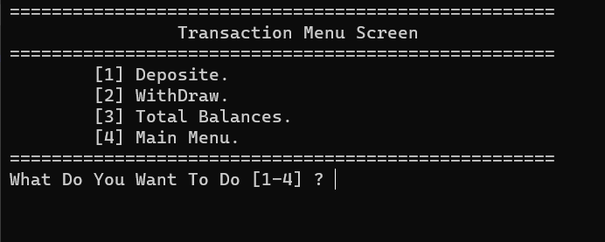

Important Note:
-If You Press 1 And The Program Crashes ->
Delete File Content And Add Clients Again From The Program.

